How to install mysql & visual C++ redistributanle 2019:

* First download mysql workbench in mysql website
* If ur system not installed with visual C++ 2019 u need to install then only mysql support to install

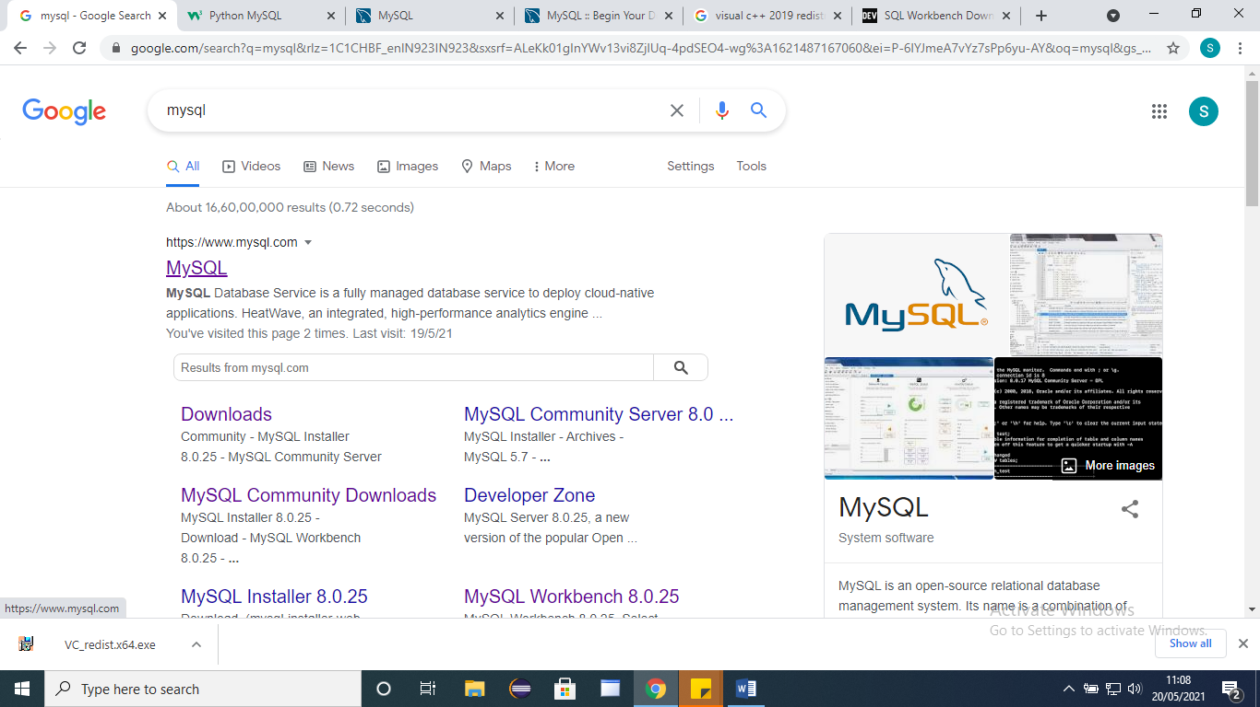

* Click downloads

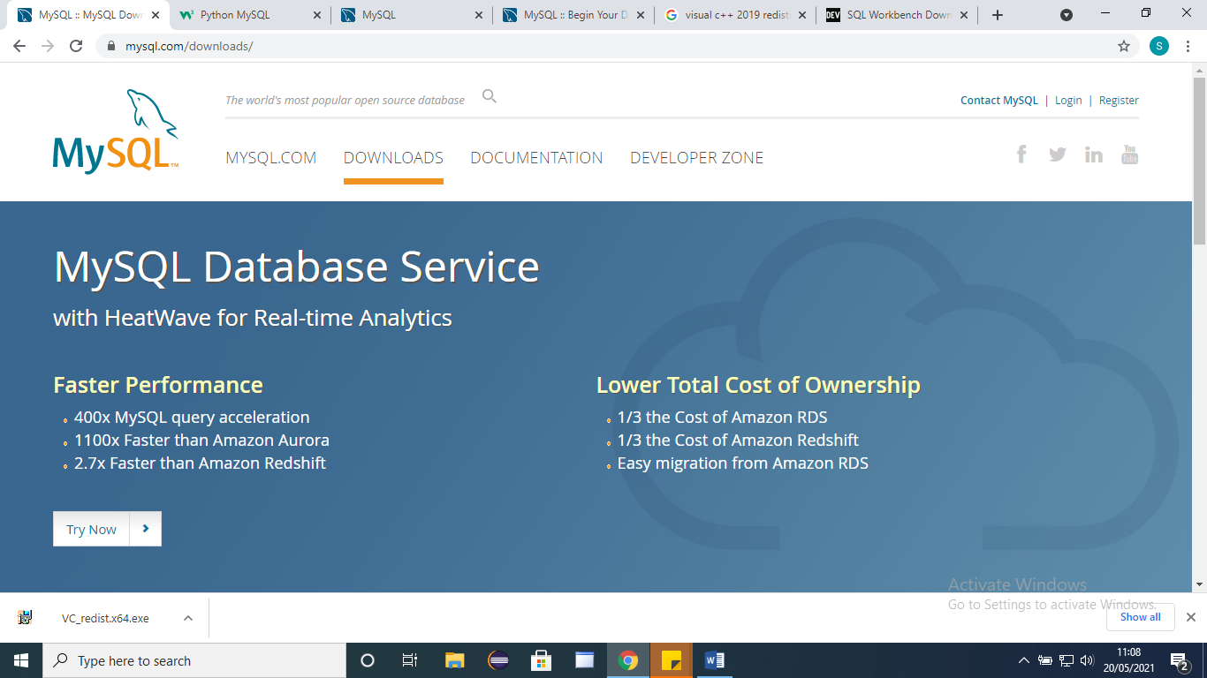

* Click mysql Community (GPL) Downloads

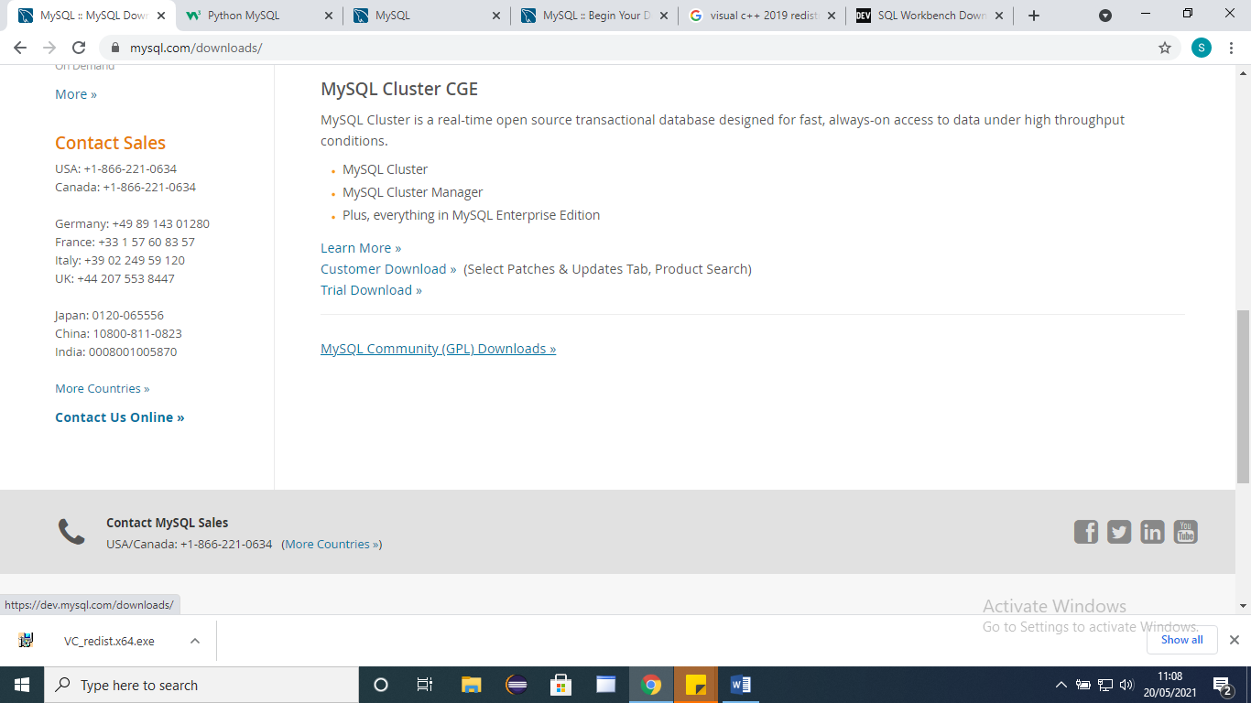

* Click mysql workbench

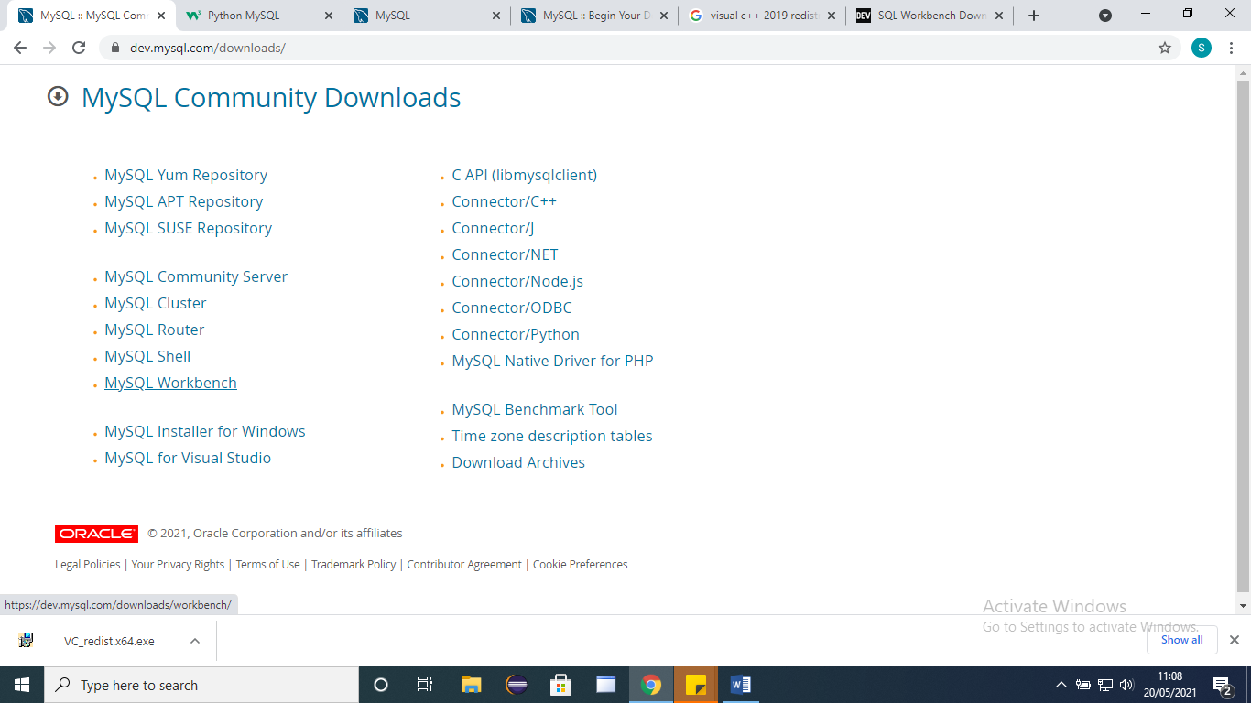

* If u already install sql server, directly install mysql workbench, otherwise u need to download Mysql installer for windows to install mysql
* Select OS type and then download

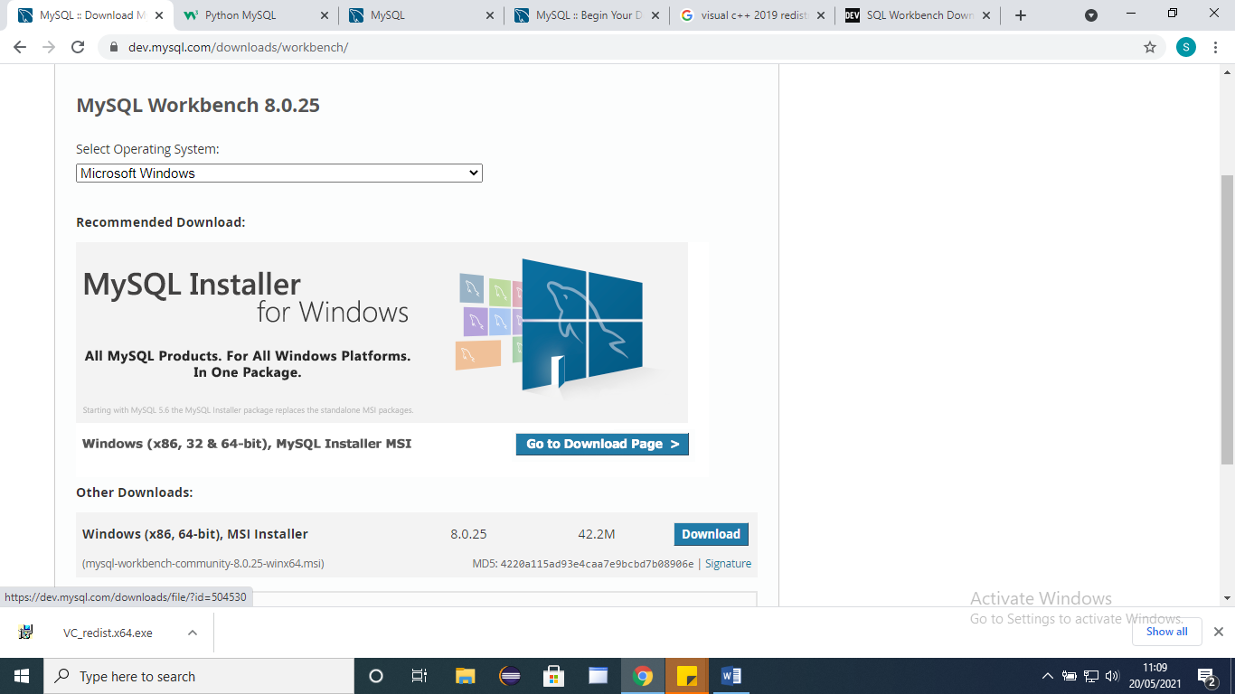

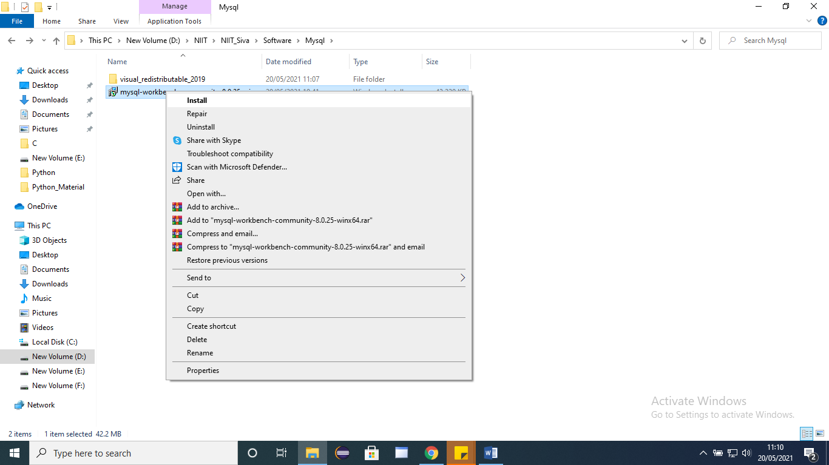

To download Visual C++ 2019 redistributable download:

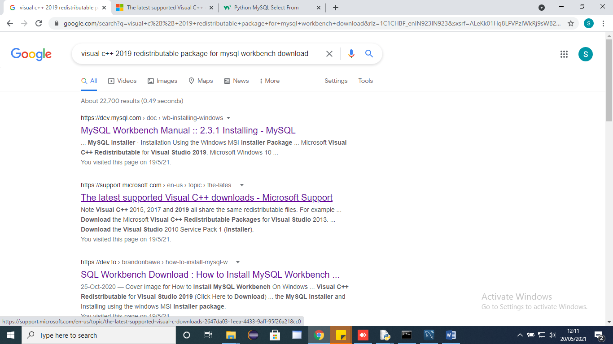

* Drag down and click depends upon ur processor bit

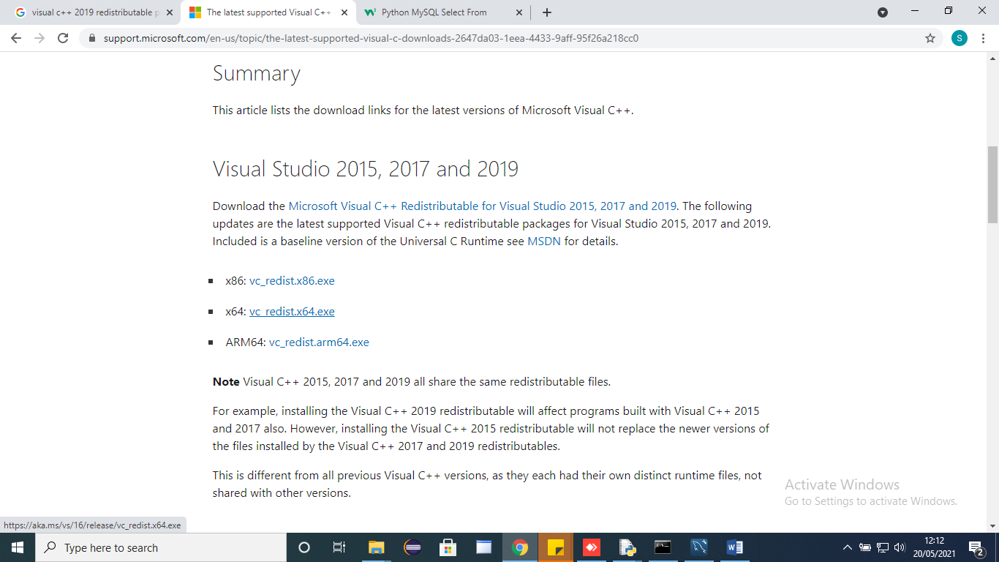

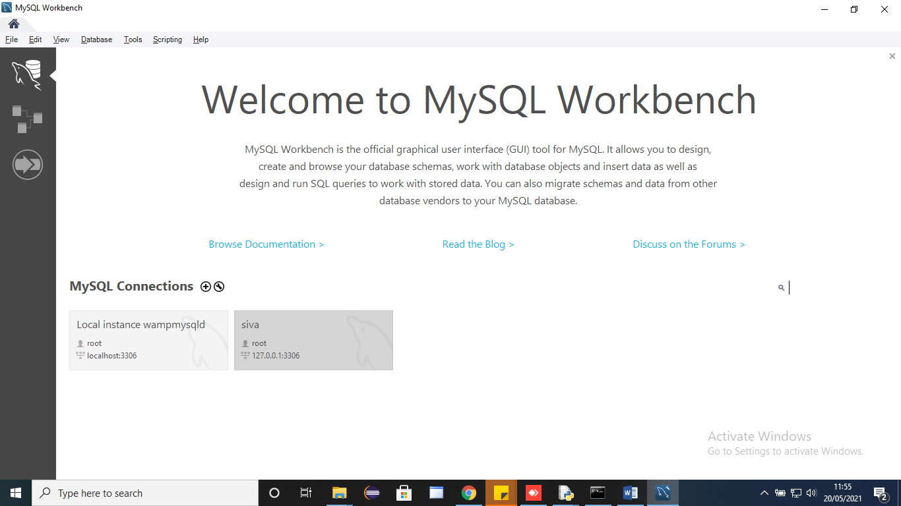

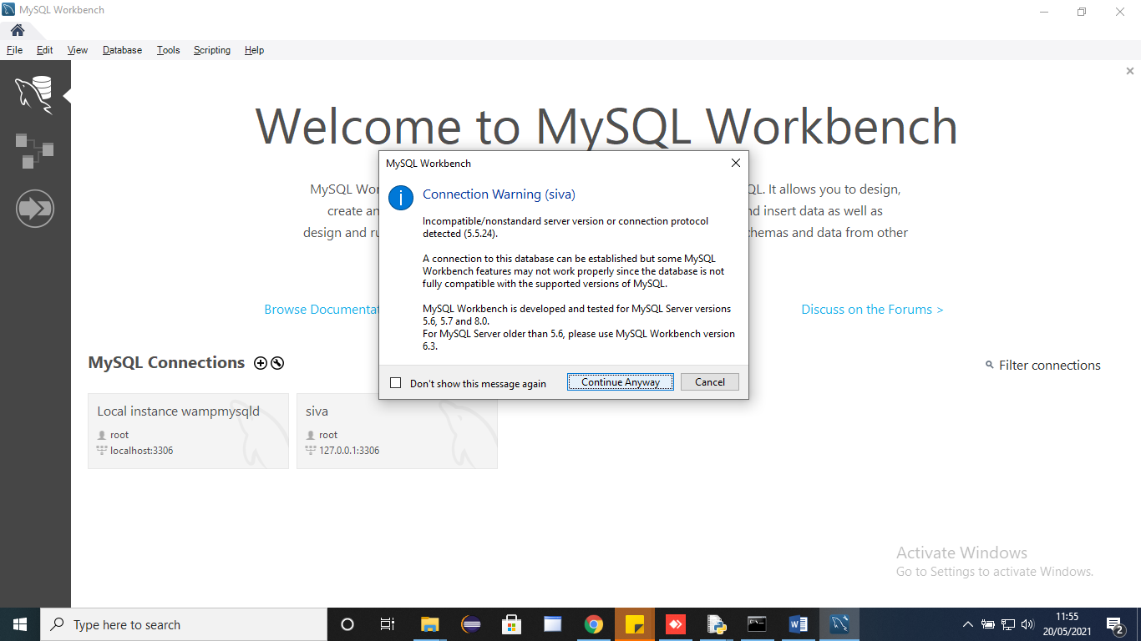

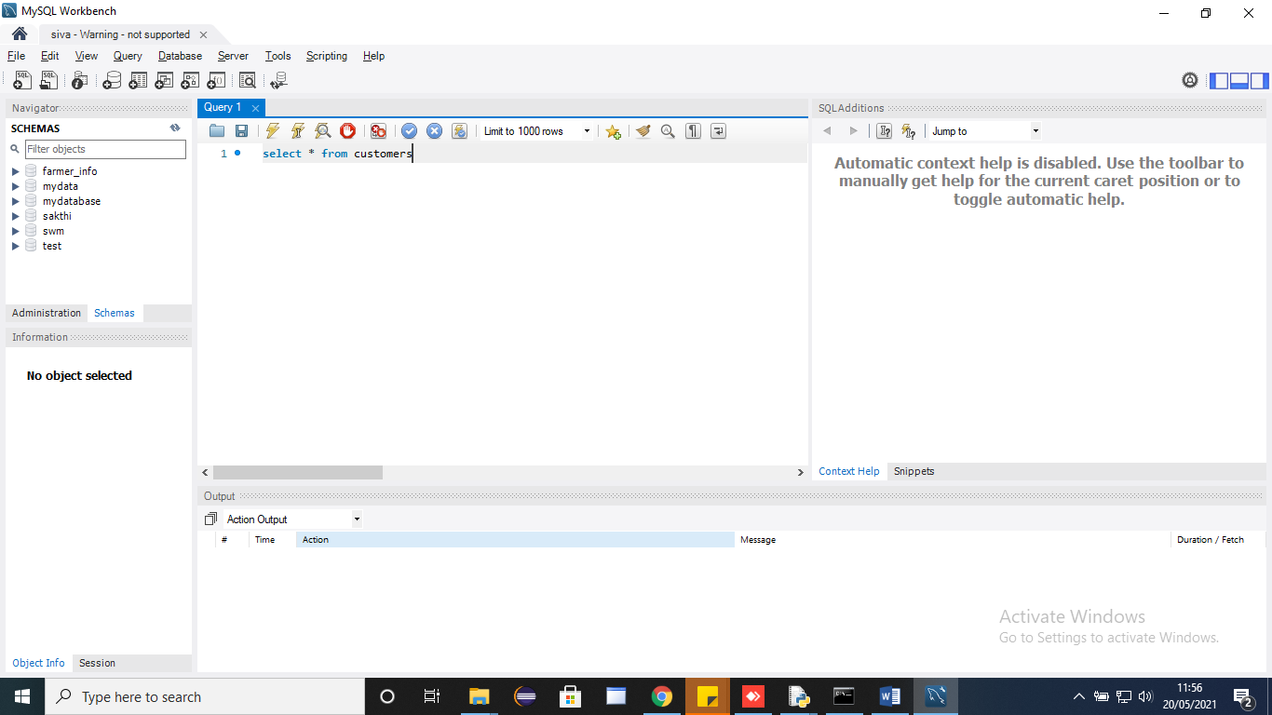

How to download Mysql connector and Procedure to connect with Eclipse:

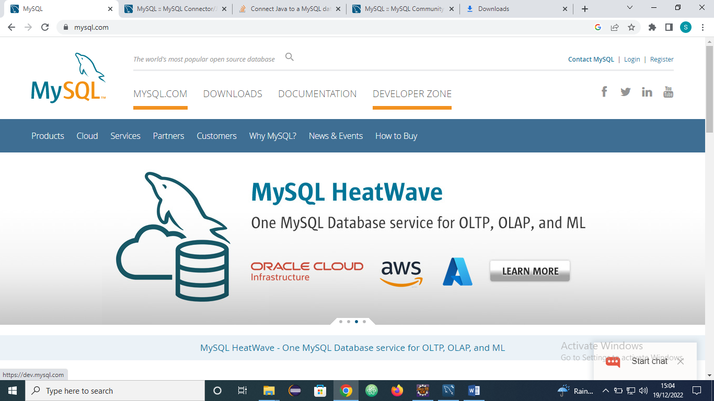

In above SS click Developer zone

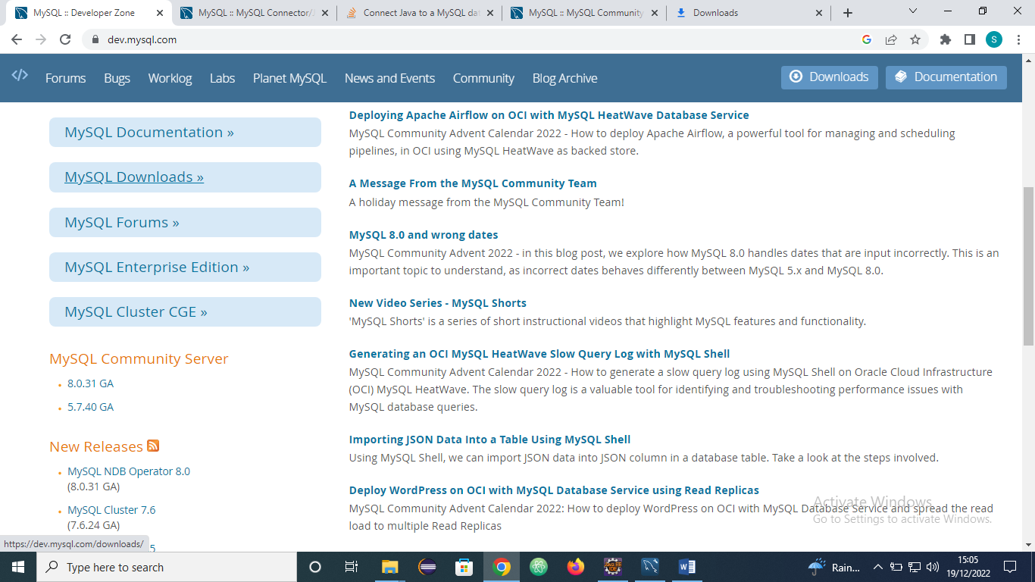

In above SS click Mysql Downloads

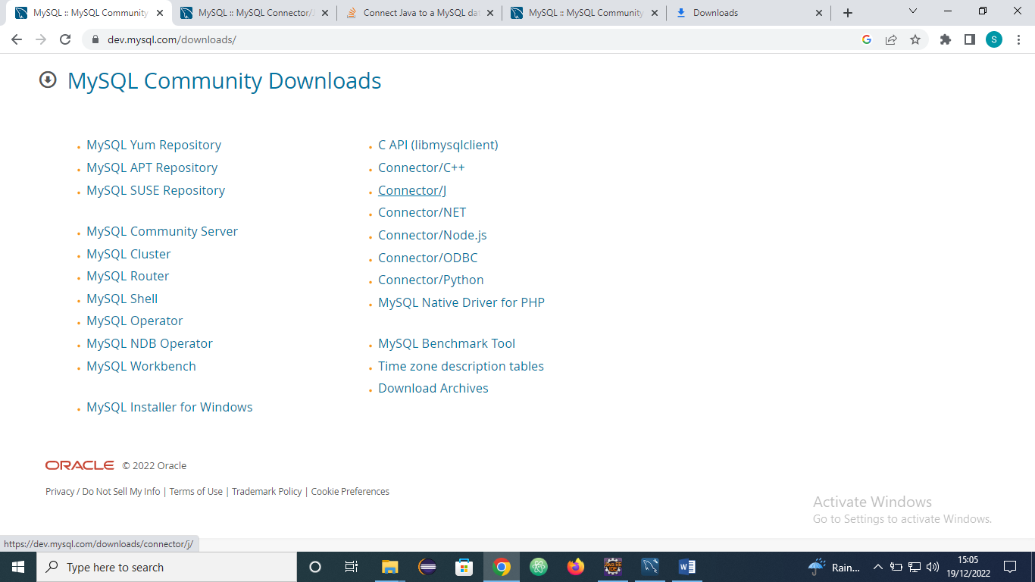

In above SS click CONNECTOR/J

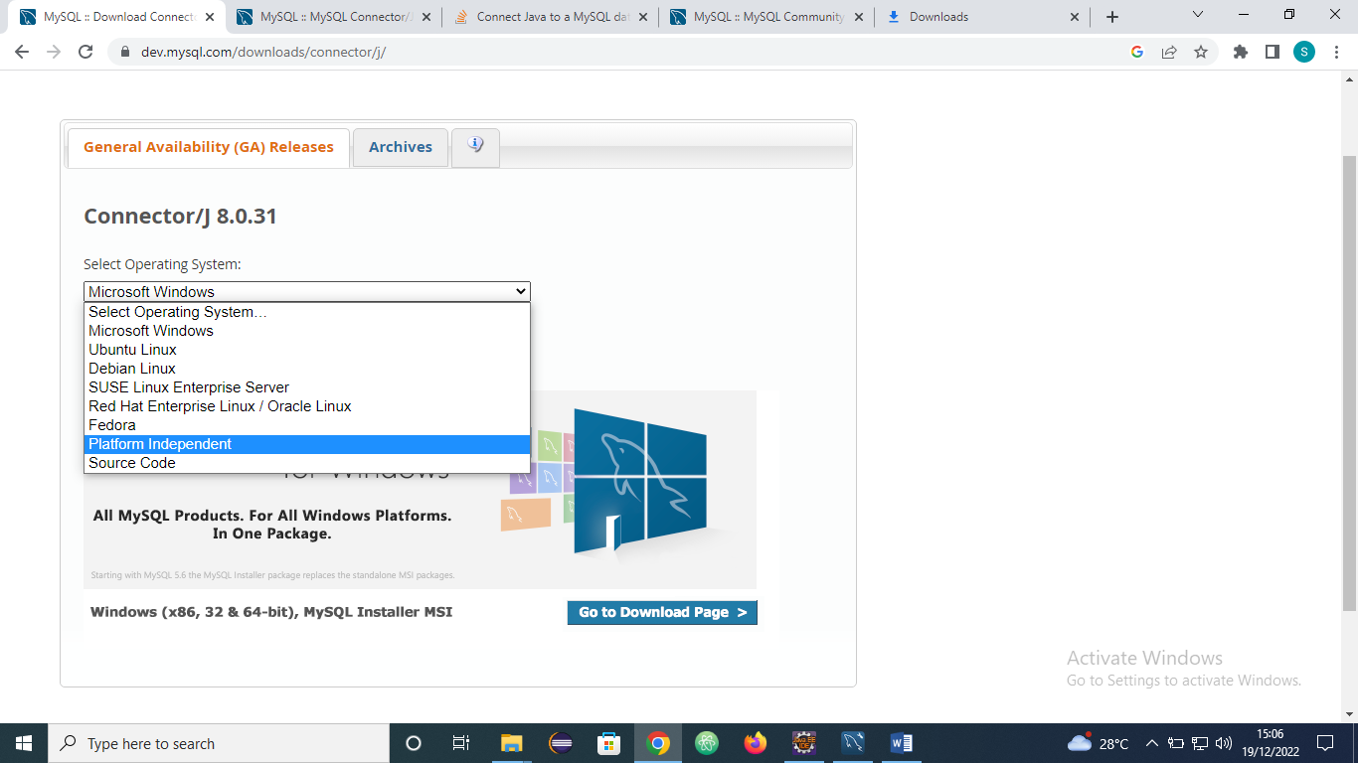

In above SS select the Platform Independent option in the dropdown

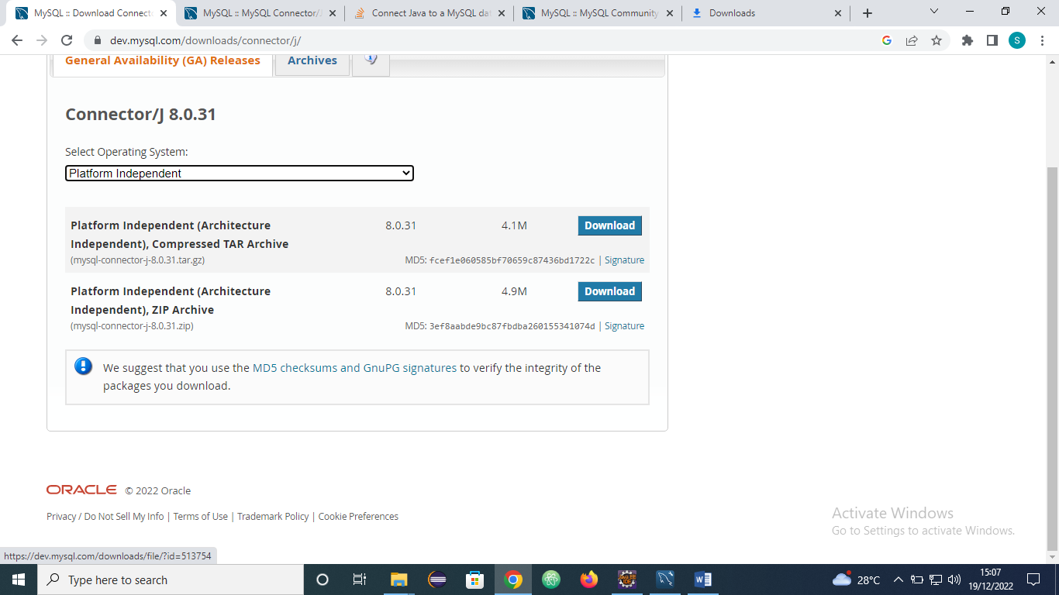

In above SS click download of second Option (Platform Independent (Architecture Independent), ZIP Archive)

After that extract the zip file